kırpıntı çizim, simge, sembol, grafik, tasarım içeren bir resim

Açıklama otomatik olarak oluşturuldu

MIDDLE EAST TECHNICAL UNIVERSITY

ELECTRICAL & ELECTRONICS ENGINEERING

2024-2025 FALL

EE463 – STATIC POWER CONVERSION I

HARDWARE PROJECT

SIMULATION REPORT

24.11.2024

Muhammet Kamer Taha GENÇ 2234748

Mustafa Burak ÇORUK 2442812

Öykü KAYAN 2516391

**Table of Contents**

**Introduction** 3

**Problem Definition** 3

**Topology Options** 3

**1)** **Single Phase Diode Rectifier with Buck Converter** 3

**2)** **Three Phase Diode Rectifier with Buck Converter** 5

**3)** **Single Phase Thyristor** 7

**4)** **Three Phase Thyristor** 9

**Topology Selection** 10

**Simulation Results** 11

**1)** **Three Phase Diode Rectifier Simulation** 13

**2)** **Buck Converter Simulation** 17

**3)** **Three Phase Diode Rectifier and Buck Converter Simulation** 19

**4)** **Controller Simulation** 25

**4.1) Speed Control Model** 25

**4.2) Generator Model** 28

**Component Selection** 31

**Conclusion** 31

**References** 31

**Introduction**

This project focuses on designing a DC motor drive system using a controlled rectifier to convert AC grid input into an adjustable DC output. The report evaluates four topologies: single-phase diode rectifiers with buck converters, three-phase diode rectifiers with buck converters, single-phase thyristor rectifiers, and three-phase thyristor rectifiers. The performance of these topologies is assessed through simulations, and based on the results, the optimal topology is selected. Suitable components are identified, and the simulation-based analysis lays the groundwork for future hardware implementation, ensuring the design meets performance and stability requirements before the prototyping phase.

**Problem Definition**

This project aims to design a controlled rectifier to power a DC motor by converting AC grid input (single-phase or three-phase) into adjustable DC output (up to 180 V).

**Key Requirements**:

* **Input**: Single-phase or three-phase AC (adjustable via variac)
* **Output**: Adjustable DC voltage, maximum 180 V
* **Topologies**: Options include:
* Single-phase diode rectifier + buck converter
* Three-phase diode rectifier + buck converter
* Single-phase thyristor
* Three-phase thyristor
* **Motor Specs**:
* Armature: 0.8 Ω, 12.5 mH
* Shunt: 210 Ω, 23 H
* Interpoles: 0.27 Ω, 12 mH

**Topology Options**

In designing a controlled rectifier to drive a DC motor, various topologies can be considered to convert the AC grid input into an adjustable DC output. The primary objective is to ensure a stable and efficient DC voltage for reliable motor operation. For this purpose, four alternative topologies for this purpose are the single-phase diode rectifier with buck converter, the three-phase diode rectifier with buck converter, the single-phase thyristor rectifier, and the three-phase thyristor rectifier, each with its own set of advantages and limitations. These topologies are discussed in detail below. These topologies are discussed in detail below.

1. **Single Phase Diode Rectifier with Buck Converter**

In this configuration, the single-phase AC input is first rectified by the diode rectifier, converting the AC into DC, as shown in Figure 1. The output of the rectifier is then processed by the buck converter, shown in Figure 2, which steps down the DC voltage to the desired level.

diyagram, teknik çizim, çizgi, taslak içeren bir resim

Açıklama otomatik olarak oluşturuldu

Figure 1: Single Phase Diode Rectifier Circuit

The first stage of the system involves converting the AC input into DC. This is done using a single-phase diode rectifier. In a single-phase full-wave rectifier, the diodes are arranged to rectify both the positive and negative halves of the AC waveform.

The output of the rectifier is a pulsating DC voltage. The average DC output voltage, which is the DC equivalent of the rectified signal, can be calculated using the following formula:

$$V_{out}= \frac{2\sqrt{2}}{π}×V_{phase}$$

However, the output voltage is still not pure DC, as it contains ripples corresponding to the AC input frequency. These ripples may affect the performance of the motor, which is why further smoothing, and regulation are needed in the next stage.

diyagram, taslak, teknik çizim, plan içeren bir resim

Açıklama otomatik olarak oluşturuldu

Figure 2: Buck Converter Circuit

A buck converter processes the resultant DC voltage after rectification to lower it to the required level. Buck converters are an example of DC-DC converter that reduces the DC voltage. In order to create a steady, lower DC voltage, it first converts the DC input into a high-frequency pulse using a switching device. Then, inductor and capacitor filter the pulse.

The duty cycle D of the buck converter, which is the ratio of the switch's on-time to the overall switching cycle period, determines the output voltage. The output voltage formula is as follows:

$$V_{out}= D×V_{in}$$

Overall formula for the system is:

$$V_{out}=D×\frac{2\sqrt{2}}{π}×V_{phase}$$

**Advantages**

* The single-phase diode rectifier is a straightforward solution to convert AC to DC, requiring fewer components than three-phase alternatives.
* Due to fewer components, the single-phase configuration is generally cheaper to implement.
* This configuration provides a straightforward yet efficient solution for smaller motors and is ideal for low-power DC motor applications.
* With fewer diodes in the conduction path, single-phase systems experience lower voltage drops across the diodes compared to three-phase systems, leading to lower conduction losses at lower current levels.

**Disadvantages**

* There are ripples in the rectified DC output that could affect motor performance, necessitating extra filtering and regulation steps.
* Compared to three-phase rectifiers, single-phase rectifiers are less effective at higher power levels.

1. **Three Phase Diode Rectifier with Buck Converter**

This configuration involves two stages: the three-phase diode rectifier and the buck converter, working together to efficiently convert and regulate the voltage supplied to the DC motor.

diyagram, çizgi, teknik çizim, plan içeren bir resim

Açıklama otomatik olarak oluşturuldu

Figure 3: Three Phase Diode Rectifier Circuit

Each of the three sinusoidal AC waveforms in a three-phase system is 120 degrees out of phase with the others. The rectifier transforms the three-phase AC input into pulsating DC by allowing current to flow through the circuit in a single direction using six diodes placed in a bridge arrangement.

The output of the three-phase rectifier is pulsating DC, and the average DC voltage is given by:

diyagram, taslak, teknik çizim, plan içeren bir resim

Açıklama otomatik olarak oluşturuldu

Figure 4: Buck Converter Circuit

Following the three-phase diode rectifier's correction of the DC voltage, the output still requires regulation and control. A buck converter, which lowers down the DC voltage to the required level, is used to do this. The formula for the output voltage is:

$$V_{out}= D×V_{in}$$

Overall formula for the system is:

$$V_{out}=D×\frac{3\sqrt{2}}{π}×V_{linetoline}$$

**Advantages**

* The output voltage from a three-phase rectifier is higher compared to a single-phase rectifier for the same input AC voltage.
* The DC output of a three-phase rectifier is smoother than that of a single-phase rectifier because it generates less ripple. This is critical for efficient and reliable motor performance, especially at higher loads.
* By better utilizing the available AC input, the three-phase system improves efficiency and regulates the DC output. For DC motor applications, where steady power delivery is crucial, this is especially advantageous.
* Three-phase rectifiers are better for larger DC motors or applications needing larger amounts of energy production since they can manage higher power levels more effectively. Performance is enhanced and energy losses are decreased as a result.

**Disadvantages**

* Compared to the single-phase option, the three-phase diode rectifier system is more complicated. To handle the three-phase AC input, it needs more parts, including six diodes and more circuitry, which extends the design time and complicates the system.
* The system is more costly to implement due to the higher number of diodes and components.
* With more diodes in the conduction path, a three-phase full-bridge rectifier experiences greater total voltage drops across the diodes during operation.

1. **Single Phase Thyristor**

A single-phase thyristor rectifier is used to convert AC voltage to a controlled DC output voltage. By using thyristors instead of standard diodes, it allows for adjustment of the output voltage, making it suitable for applications that require variable DC voltage.

diyagram, taslak, çizgi, teknik çizim içeren bir resim

Açıklama otomatik olarak oluşturuldu

Figure 5: Single Phase Thyristor Circuit

A single-phase thyristor rectifier operates by converting AC into DC while allowing control over the output voltage using thyristors. During each half-cycle of the AC input, the thyristors remain off until they receive a gate pulse at a specific firing angle α. Once triggered, the thyristor conducts, allowing current to flow through the load. By adjusting the firing angle α, which ranges from 0° to 180°, the conduction period of the thyristors is altered. A smaller firing angle results in a higher output voltage, as the thyristor turns on earlier in the cycle, while a larger firing angle reduces the output voltage by delaying conduction. This control over the firing angle enables the rectifier to provide a variable DC output voltage.

The average DC voltage of single-phase thyristor is given by:

**Advantages**

* The ability to adjust the firing angle provides control over the output voltage, which is ideal for applications needing variable DC voltage.
* Thyristors have low conduction losses, making the rectifier stage efficient.
* Compared to more complex multi-phase systems, a single-phase thyristor rectifier has a simpler design and fewer components, making it cost-effective.

**Disadvantages**

* Unlike diode-based rectifiers, thyristor rectifiers require an additional control circuit for triggering the thyristors at the correct firing angle.
* The output of the thyristor rectifier is pulsating DC, which can still affect sensitive loads, requiring additional filtering and smoothing to produce a more stable DC output.

1. **Three Phase Thyristor**

A three-phase thyristor rectifier is used to convert three-phase AC voltage into a controllable DC output. Like the single-phase thyristor rectifier, this system uses thyristors instead of diodes, allowing the output voltage to be controlled by adjusting the firing angles of the thyristors. The main advantage of using a three-phase system over a single-phase one is that it provides a higher DC output voltage and better efficiency.

diyagram, çizgi, teknik çizim içeren bir resim

Açıklama otomatik olarak oluşturuldu

Figure 6: Three Phase Thyristor Circuit

In a three-phase thyristor rectifier, each of the six thyristors is triggered by a gate pulse at a specific firing angle, α, during the positive and negative half-cycles of the three-phase AC input. Each thyristor only conducts for a portion of the AC cycle, depending on when it is triggered, thereby controlling the duration and phase of the current flowing through the load. This allows for precise control of the average DC output voltage, like the single-phase system, but with a higher and more stable voltage due to the nature of the three-phase input.

The average DC voltage of three-phase thyristor is given by:

**Advantages**

* The output DC voltage is significantly higher compared to single-phase rectifiers for the same input AC voltage, making it more suitable for high-power applications.
* Three-phase systems provide a smoother DC output compared to single-phase systems, as the voltage ripple is reduced.
* Three-phase systems provide more consistent power delivery and better utilization of the AC input.

**Disadvantages**

* The control system for a three-phase thyristor rectifier is more complex than for a single-phase system, as it requires precise timing of the gate pulses for each of the six thyristors. This increases design complexity and costs.
* Like all thyristor-based rectifiers, three-phase thyristor rectifiers generate harmonic distortions.
* Although smoother than single-phase systems, the output from a three-phase thyristor rectifier is still pulsating DC, which might not be suitable for applications requiring a very smooth and stable DC output. Additional filtering is often required.
* The use of more components and the need for a complex control system make three-phase thyristor rectifiers more expensive to implement than simpler rectifier circuits.

**Topology Selection**

After carefully evaluating the advantages and disadvantages of the four topologies—single-phase diode rectifier with buck converter, three-phase diode rectifier with buck converter, single-phase thyristor rectifier, and three-phase thyristor rectifier—the decision was made to select the three-phase diode rectifier with buck converter topology for the motor drive application.

**Higher Output Voltage**: The three-phase diode rectifier with buck converter offers a significantly higher DC output voltage compared to the single-phase systems, making it ideal for high-power motor applications. When combined with the buck converter, the system is capable of efficiently stepping down the voltage while maintaining stability.

**Smoother DC Output**: The integration of the three-phase diode rectifier with the buck converter results in a smoother DC output. A three-phase rectifier inherently produces less ripple in the DC output compared to single-phase systems. When this is paired with a buck converter, which further smooths the voltage, the result is an even more stable DC supply for the motor. This contrasts with thyristor rectifiers, which, despite offering adjustable voltage, still tend to introduce more ripple.

**Increased Efficiency**: For high-power motor applications, the three-phase diode rectifier with buck converter topology is more efficient than both single-phase systems and three-phase thyristor rectifiers. The three-phase rectifier ensures that the system operates with lower ripple and fewer losses, while the buck converter improves efficiency by stepping down the voltage only when necessary. Thyristor rectifiers, although they offer voltage control, are typically less efficient in high-power applications due to the increased switching and conduction losses inherent in thyristors.

**Simplified Control and Design:** The three-phase diode rectifier with buck converter combination simplifies the control system compared to a three-phase thyristor rectifier. While thyristor-based systems require complex control mechanisms to adjust the firing angle and timing of the gate pulses, the diode rectifier system with the buck converter requires less sophisticated control. The diode rectifier operates with a simpler and more reliable design, reducing both system complexity and cost.

**Simulation Results**

The parameter selection process for the simulations involves two key stages.

In the first stage, components for the three-phase diode rectifier are selected based on the guidelines provided in HW-1 of the EE463 course. Once these components are chosen, the system is simulated to ensure satisfactory performance. If the results meet the expected criteria, these components are retained for the subsequent stages of the design.

In the second stage, parameters for the buck converter are carefully selected to ensure the output voltage is reduced to a maximum of 180V, which depends on the duty cycle (D) and the efficiency of the components. The efficiency of the MOSFET, diode, inductor, and capacitor are key factors in determining the output voltage, and the following equation is used to maintain a 180V output:

The selection of inductance, capacitance, and resistance values plays a crucial role in the buck converter simulation. A resistance of 20 ohms is chosen, as it is a balanced value that is neither too low nor too high. This resistance value impacts the mode of operation, which can either be Discontinuous Conduction Mode (DCM) or Continuous Conduction Mode (CCM). To ensure the converter operates in CCM, used formulas are:

During our research on switching frequency, we found that frequencies between 20-30 kHz are commonly used for semi-professional applications like ours. Based on this, we set the switching frequency at 25 kHz.

The first parameter that we can arrange is ripple of the inductance current because it depends on the duty cycle, output voltage, switching frequency and inductance. Given an average inductor current of 9.1 A (based on the duty cycle D=0.35 derived from the equation 9​, where the efficiency was approximately 0.995), we targeted an inductor current ripple of 1-1.5 A. However, it should be noted that this value may change in a real application with actual components. Simulations using real component values will be presented in this report and the final report.

From equation 10:

With the inductance value set, we then calculated the capacitance to limit the voltage ripple. Our desired output voltage is 180 V, and we aimed for a voltage ripple of no more than 2.5%, which corresponds to:

Using the formula 11 for the output capacitor ripple:

To ensure better filtering and accommodate real-world variations, we increased the capacitance to 3 µF. This value also helps meet the corner frequency requirement. Corner frequency is the frequency at which the response of a system (such as a filter, amplifier, or control system) begins to decline or change.[1]

The formula for calculating the corner frequency is:

In our EE463 lectures, it was highlighted that the corner frequency should be set lower than the switching frequency to maintain safe operating conditions for the components. During the initial power flow, there may be ringing in the circuit, and special attention must be given to the corner frequency point. This is because if the gain of the filter increases unexpectedly due to ringing at the corner frequency, it could result in excessive voltage and current spikes, much higher than the expected values, potentially damaging the components.

For our buck converter, using L=3 mH and C=3 uF, the corner frequency is calculated as:

1. **Three Phase Diode Rectifier Simulation**

diyagram, plan, teknik çizim, çizgi içeren bir resim

Açıklama otomatik olarak oluşturuldu

Figure 7: Three Phase Diode Rectifier Circuit

Figures 8, 9, and 10 illustrate the results obtained from the diode rectifier configuration based on the parameters specified in EE463 Homework 1.

metin, ekran görüntüsü, yazı tipi, sayı, numara içeren bir resim

Açıklama otomatik olarak oluşturuldu

Figure 8: Diode Rectifier Diodes Voltage and Current vs. Time Waveform

metin, ekran görüntüsü, yazı tipi, öykü gelişim çizgisi; kumpas; grafiğini çıkarma içeren bir resim

Açıklama otomatik olarak oluşturuldu

Figure 9: Output Voltage and Input Phase Current vs. Time Waveform

metin, ekran görüntüsü, yazı tipi, çizgi içeren bir resim

Açıklama otomatik olarak oluşturuldu

Figure 10: Output Voltage and Input Phase Current vs. Time Waveform from Closer Perspective

Figures 11, 12, and 13 depict the performance of the combined diode rectifier and buck converter circuit, using component parameters from calculations.

**metin, ekran görüntüsü, yazı tipi, sayı, numara içeren bir resim

Açıklama otomatik olarak oluşturuldu**

Figure 11:Diode Rectifier Diodes Voltage and Current vs. Time Waveform

**metin, öykü gelişim çizgisi; kumpas; grafiğini çıkarma, çizgi, ekran görüntüsü içeren bir resim

Açıklama otomatik olarak oluşturuldu**

Figure 12: Output Voltage and Input Phase Current vs. Time Waveform

**metin, ekran görüntüsü, öykü gelişim çizgisi; kumpas; grafiğini çıkarma, çizgi içeren bir resim

Açıklama otomatik olarak oluşturuldu**

Figure 13: Output Voltage and Input Phase Current vs Time Waveform From Closer Perspective

metin, ekran görüntüsü, öykü gelişim çizgisi; kumpas; grafiğini çıkarma, çizgi içeren bir resim

Açıklama otomatik olarak oluşturuldu

Figure 14: Diodes Upper-side Current vs Time Waveform From Closer Perspective

Figures 8 and 11 show us we should select diodes which have (around) 600 V repetitive peak reverse voltage. Figure 11 shows us this value is quite enough because it is %20 more than peak reverse voltage, it says peak value of the simulation results will be in safety margin when we select diode as 600V or more.

Figure 12 (and figure 13 for closer perspective) indicates that circuit gives enough good output voltage and voltage ripple to the buck converter, which is around 465V, and ripple is less than %4 from peak to peak. Input phase a current is going up to 25A and the current at the output of the three diode is like figure 14. 10mH source inductor and 100uF capacitor give us these simulation results.

These results are good enough for this project and results will be change with buck converter integration, but as a result of integrated circuit simulations these changes will not be too much effective.

1. **Buck Converter Simulation**

metin, yazı tipi, ekran görüntüsü, tasarım içeren bir resim

Açıklama otomatik olarak oluşturuldu

Figure 15: MOSFET Drain to Source Voltage and Current vs. Time of the Buck Converter

metin, ekran görüntüsü, yazı tipi, tasarım içeren bir resim

Açıklama otomatik olarak oluşturuldu

Figure 16: Diode Voltage and Current vs. Time of the Buck Converter

metin, ekran görüntüsü, yazı tipi, çizgi içeren bir resim

Açıklama otomatik olarak oluşturuldu

Figure 17: Inductance Voltage, Output Voltage and Inductance Current vs. Time of the Buck Converter

metin, ekran görüntüsü, yazı tipi, tasarım içeren bir resim

Açıklama otomatik olarak oluşturuldu

Figure 18: Inductance Voltage, Output Voltage and Inductance Current vs. Time from closer perspective of the Buck Converter

Figures 15-16-17-18 are the results for buck converter simulations. Still rectifier and buck converter are not connected each other, so these results are not final results for component selection, but they are good perspective decider and result for the system behavior. Figures 15 and 16 are very important for diode and MOSFET selection, we expect quite close results as a ratio (ratio between input and output current of the buck converter). Inductor behavior can be seen at figure 17 and 18. From figure 17 we see that the output voltage becomes higher and higher until the desired value. This behavior occurs because output capacitor and inductor are charging at the beginning of the process and as it can be seen from figure 18 after stability, output voltage ripple and inductor current ripple are quite small and smooth. As a result of duty cycle we see that the inductance voltage is going between 345V and -180V.

1. **Three Phase Diode Rectifier and Buck Converter Simulation**

diyagram, plan, teknik çizim, şematik içeren bir resim

Açıklama otomatik olarak oluşturuldu

Figure 19: Connected Circuit of Three Phase Diode Rectifier and Buck Converter (Non-ideal Conditions)

ekran görüntüsü, metin, çizgi içeren bir resim

Açıklama otomatik olarak oluşturuldu

Figure 20: Phase a Input Current and Output Voltage vs. Time of Three Phase Diode Rectifier

metin, ekran görüntüsü, yazı tipi, çizgi içeren bir resim

Açıklama otomatik olarak oluşturuldu

Figure 21: Closer Perspective for Input Phase Current and Output Voltage of Three-phase Diode Rectifier After Power Flow Starts and Circuit Becomes Stable

metin, ekran görüntüsü, çizgi, öykü gelişim çizgisi; kumpas; grafiğini çıkarma içeren bir resim

Açıklama otomatik olarak oluşturuldu

Figure 22: Diodes Upper-side Current vs Time Waveform From Closer Perspective

metin, ekran görüntüsü, çizgi, öykü gelişim çizgisi; kumpas; grafiğini çıkarma içeren bir resim

Açıklama otomatik olarak oluşturuldu

Figure 23: Inductance Voltage, Output Voltage and Inductance Current vs. Time of the Buck Converter

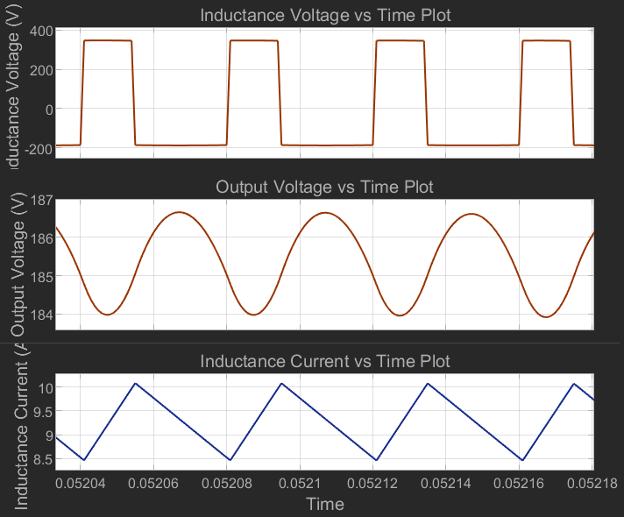

Figure 24: Closer Perspective for Inductance Voltage, Output Voltage and Inductance Current vs. Time of the Buck Converter After Power Flow Starts and Circuit Becomes Stable

metin, ekran görüntüsü, yazı tipi, piyano içeren bir resim

Açıklama otomatik olarak oluşturuldu

Figure 25: Diode Voltage and Diode Current vs. Time for the Three-phase Diode Rectifier

metin, ekran görüntüsü, öykü gelişim çizgisi; kumpas; grafiğini çıkarma, çizgi içeren bir resim

Açıklama otomatik olarak oluşturuldu

Figure 26: Buck Converter Diode Voltage and Current vs. Time

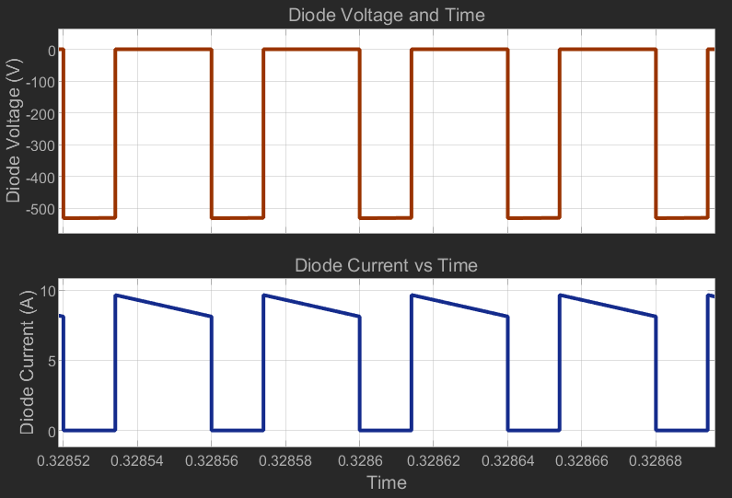

Figure 27: Buck Converter Diode Voltage and Current vs. Time After Circuit Becomes Stable

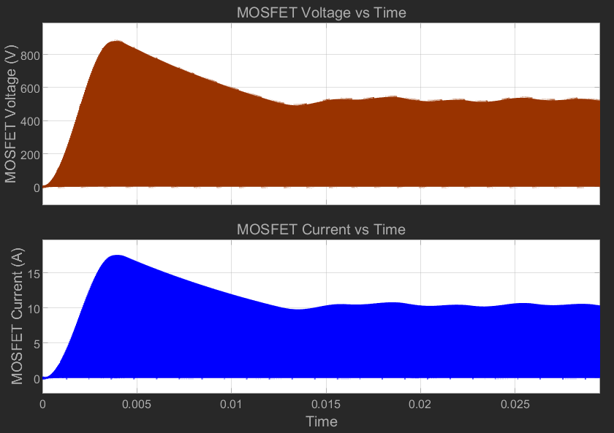

Figure 28: Buck Converter Switching MOSFET Voltage and Current vs. Time.

metin, ekran görüntüsü, yazı tipi, tasarım içeren bir resim

Açıklama otomatik olarak oluşturuldu

Figure 29: Buck Converter Switching MOSFET Voltage and Current vs. Time after circuit becomes stable.

These figures (figures from number 19 to number 29) are the schematic/results of the Simulink simulations of the integrated three phase diode rectifier and buck converter circuit while the duty cycle is 0.35.

We see that these results are similar (at least similar as a shape but not numerical) to the sub-blocks simulations which are given at first and second part of this section.

Figure 21 shows that there is good enough DC voltage at the output of the rectifier (so at the beginning of the buck converter) which has 524 V mean and rms voltage and 3% ripple. Phase current could be better, but, since there is an inductor at the buck converter this ripple of the current at the rectifier side is not a problem. At figure 22 there is too much ripple of the current which is going through output of the rectifier, but current result of the buck converter output current is enough good as it can be seen from figure 24. This current result fits our calculations and shows us we can use these parameter values for component selection. Output voltage ringing is less than 2% (almost 1%) is also enough for this project.

As a result of these simulations, we can say diode of the rectifier should have (at least) 600V reverse voltage capability as repetitive peak value and also should handle 20 A as a peak (at the beginning) and 4-5 A as a continuous value. Inductor of the buck converter will have 350 V and – 180 V voltage value while it has the current between 8.5-10 A. Selection of the diode of the buck converter is also very important and this diode should have at least 550*1.2 = 660V repetitive reverse voltage peak value while the current is up to 10 as continuous value. MOSFET selection is quite important for switching, duty cycle, output current and voltage ripple or value (mean and peak value both). Therefore figures 28 and 29 are very important and they should be examined carefully. Figure 29 shows that continuous current is 10 A peak and voltage value (which should be cut during the switch close times ((1-D) Ts)) is 524 V at least. Of course, these values can vary with duty cycle and variac opening ratio at the laboratory. For this duty cycle and circuit parameters, MOSFET sees 900 V voltage and 18 A current at the beginning of the switching process, until circuit becomes stable point. Under these information and results, circuit components will be selected at the “Component Selection” part of this report.

1. **Controller Simulation**

### **4.1) Speed Control Model**

diyagram, metin, plan, dikdörtgen içeren bir resim

Açıklama otomatik olarak oluşturuldu

Figure 30: Simulation Model for Speed Control

**NOTE: Motor current is not limited in this model, however, since the current rating of the motor is 23A this current should be limited which will cause output power to be even less. Furthermore, diode MOSFET currents will be more realizable like in the speed controller. Due to assumed parameters in motor and generator the loss is great and only 2kW can be generated from 10kW.**

çizgi, metin, öykü gelişim çizgisi; kumpas; grafiğini çıkarma, ekran görüntüsü içeren bir resim

Açıklama otomatik olarak oluşturuldu

Figure 31: Voltage and Current on the Diode

metin, çizgi, öykü gelişim çizgisi; kumpas; grafiğini çıkarma, ekran görüntüsü içeren bir resim

Açıklama otomatik olarak oluşturuldu

Figure 32: Rectifier Output Voltage

metin, ekran görüntüsü, öykü gelişim çizgisi; kumpas; grafiğini çıkarma, diyagram içeren bir resim

Açıklama otomatik olarak oluşturuldu

Figure 33: Voltage and Current on the MOSFET

metin, çizgi, öykü gelişim çizgisi; kumpas; grafiğini çıkarma, diyagram içeren bir resim

Açıklama otomatik olarak oluşturuldu

Figure 34: Voltage and Current on the Motor

metin, çizgi, diyagram, öykü gelişim çizgisi; kumpas; grafiğini çıkarma içeren bir resim

Açıklama otomatik olarak oluşturuldu

Figure 35: Speed Controller Command, Measurement, and Error

metin, çizgi, öykü gelişim çizgisi; kumpas; grafiğini çıkarma, diyagram içeren bir resim

Açıklama otomatik olarak oluşturuldu

Figure 36: Current Controller Command, Measurement, and Error

The speed control model is constructed for 150 rad/s speed control (desired speed of the motor) which is calculated as 157 rad/s (rated) according to the configuration and parameters of the motor. Speed controller command and the speed result can be seen at figure 35. According to figures 31-32-33 our motor driver starts to work but at the second 1 (1 second after we give the electricity to the driver) it starts to excite motor. At figure 31 it is clear that we charge the capacitors until the end of the 1st second, and figure 32 (rectifier output voltage graph) Figure 33 (MOSFET Voltage) shows us this capacitor charging process. We can understand that until our system comes to the excitation point there is no current flow through motor (from figure 34) and no speed at the rotor of the motor (figure 35).

This information tells us that we need diodes for the three-phase rectifier which can stop 250 V reverse voltage and let 35 A current at least. Of course we should think about the safety margin which can be thought of as 20-25%. Therefore, we should select diodes of the rectifier as 300-320 V voltage and 42-45 A simulation result values in safety margin. From figure 33, we can think about MOSFET parameters. The voltage value of the MOSFET should be 255*1.2 or 255*1.25 V voltage in safety margin which implies 305-325 V, and 17*1.2 or 17*1.25 A current in safety margin which implies 20-22 A.

For security there is current control for the motor which can be seen from figure 36. We set the limit as 20A to be able to prevent any problem on the motor since it will be 20A*180V = 3.6kW power on the motor (which can be thought as 9 times desired value, also almost 2 times of the tea bonus desired value). However, the buck converter output voltage should not be thought of as motor input voltage (current also), figure 34 shows us the current and voltage value of the motor and we can say there is 1.2-1.5 kW power on the motor (80V*15A or 100V*15A).

### **4.2) Generator Model**

metin, diyagram, plan, ekran görüntüsü içeren bir resim

Açıklama otomatik olarak oluşturuldu

Figure 37: Simulation Model for Generator

çizgi, öykü gelişim çizgisi; kumpas; grafiğini çıkarma, ekran görüntüsü, meneviş mavisi içeren bir resim

Açıklama otomatik olarak oluşturuldu

Figure 38: Voltage and Current on the Diode

metin, öykü gelişim çizgisi; kumpas; grafiğini çıkarma, diyagram, çizgi içeren bir resim

Açıklama otomatik olarak oluşturuldu

Figure 39: Voltage and Current on the MOSFET

öykü gelişim çizgisi; kumpas; grafiğini çıkarma, çizgi, metin, diyagram içeren bir resim

Açıklama otomatik olarak oluşturuldu

Figure 40: Voltage, Current, and Power of the Motor

metin, çizgi, öykü gelişim çizgisi; kumpas; grafiğini çıkarma, diyagram içeren bir resim

Açıklama otomatik olarak oluşturuldu

Figure 41: Voltage, Current, and Power of the Generator

This model (Figure 37) is constructed for generator mode. We drive the motor thanks to rectifier + buck converter and this motor rotates the generator to push it generate power. For this configuration we can say output (motor + generator system is output part, rectifier + buck converter system is input part) of the system requires more power from the input, so we see while the diodes voltages are the same with motor model, current demand is increased (figure 38) to be able to increase input power (figure 40). Diode current increased up to 90 A for this operation while the voltage is around 255 V. MOSFET current is also increased up to 50 A while the voltage is around 255 V.

For this operation motor voltage, current and power are at the figure 40 and they are around 180 V, 50 A and 9 kW respectively. For these motor results we can only take 2 kW generator power, while the current and voltage of the generator are 18A and 110V respectively.

As it was indicated at the beginning of the controller simulation part, motor rated current is 23 A, and this means that we cannot operate the motor and generator as we found from the simulation. 90 A current for the motor is not possible therefore these results are not valid for this project.

**Component Selection**

For the PWM generator part, switching frequency of 25 kHz and duty cycle of 0.35 is chosen. We have considered a variety of components, each suited for different aspects of the design, including the Arduino, STM32, and the ESP32.

The Arduino is a flexible and easy-to-use option for generating PWM signals. With built-in functions, it can produce PWM signals on its digital output pins, allowing for adjustable duty cycles and frequencies. But, its precision and power efficiency may not meet the needs of high-frequency applications. Also, Arduino is not a real-time system. So, it may not be feasible while utilizing control loop.

The ESP32 is a flexible microcontroller with dual-core processing and the ability to generate PWM signals at up to 40 kHz. It is a good middle ground, offering high-frequency PWMgeneration, real-time control. But it may not offer the same precision as the STM32.

The STM32 microcontroller is a high-performance option for generating PWM signals, offering high-frequency PWM capabilities and precise control. The STM32 can handle complex control loops and real-time processing, making it ideal for applications that require high precision and performance, such as motor control. After careful evaluation, we have chosen the STM32 microcontroller for our PWM generation.

**Conclusion**

**References**

[1] "Cutoff frequency," *Wikipedia*. [Online]. Available: <https://en.wikipedia.org/wiki/Cutoff_frequency>. [Accessed: 16-Nov-2024].